- From your Workday home page, select the three dots on the left side below the search bar, then select Learning.

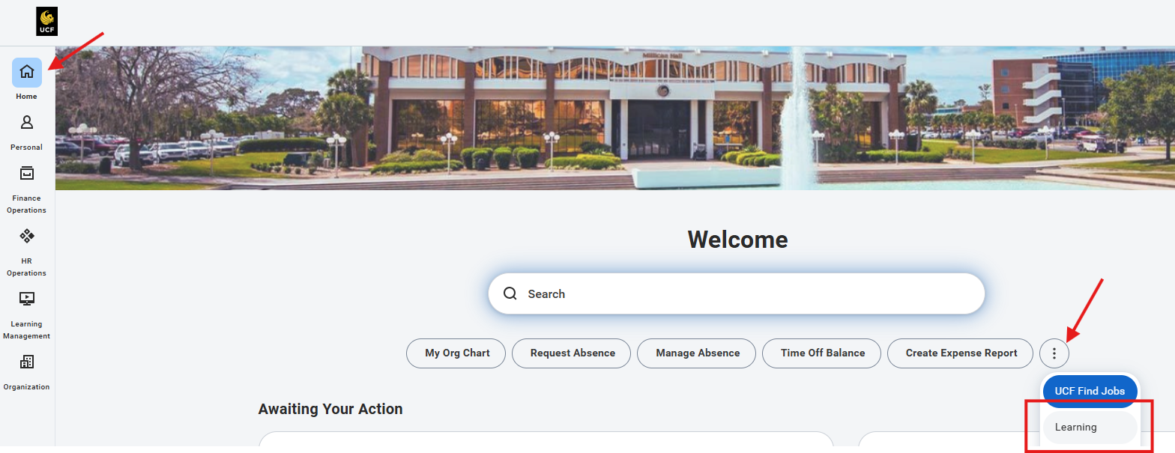

- Click Discover, then select Browse Topics.

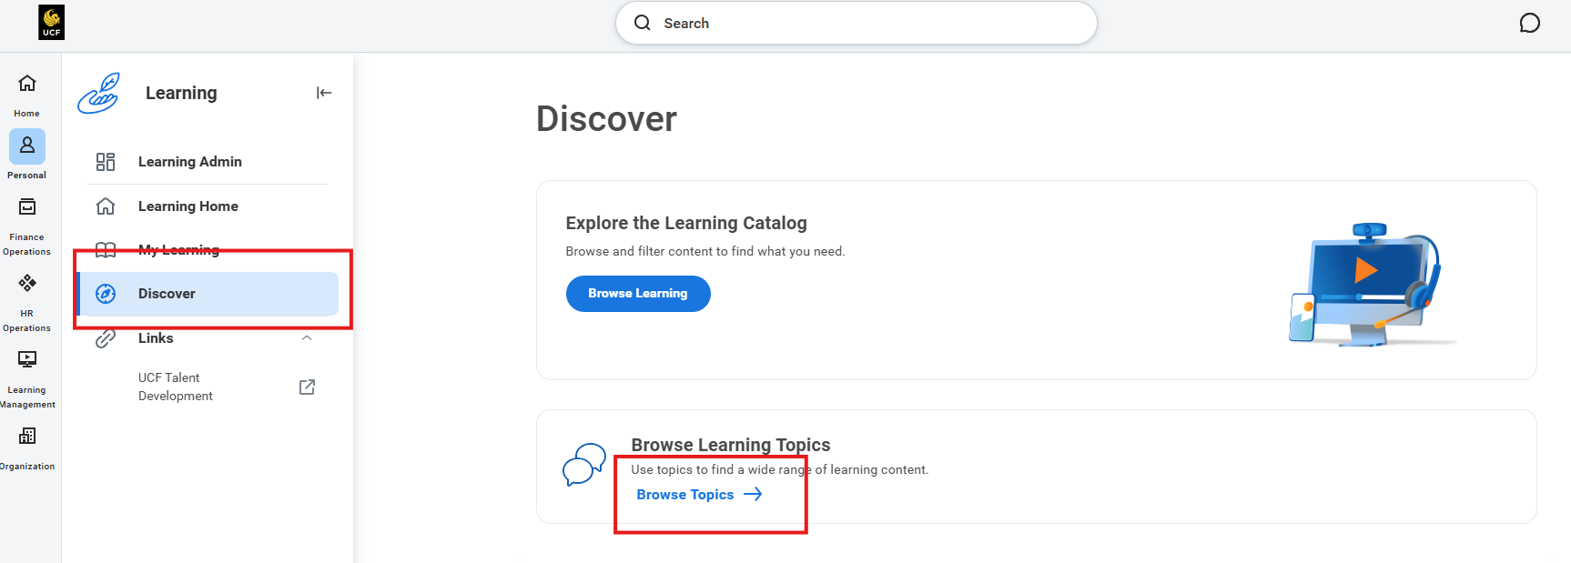

- From the Topics list, select Environmental Health and Safety (EHS).

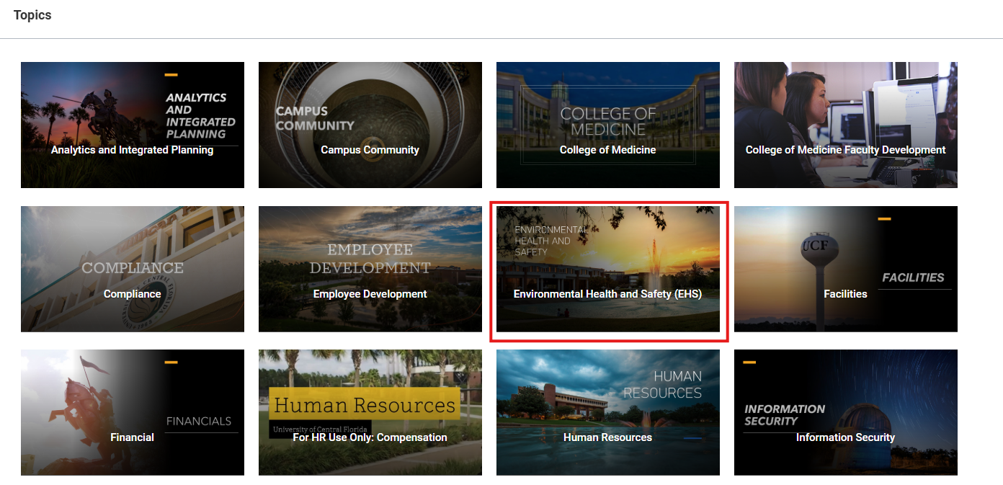
- A complete list of available EHS courses will be displayed on the page.

